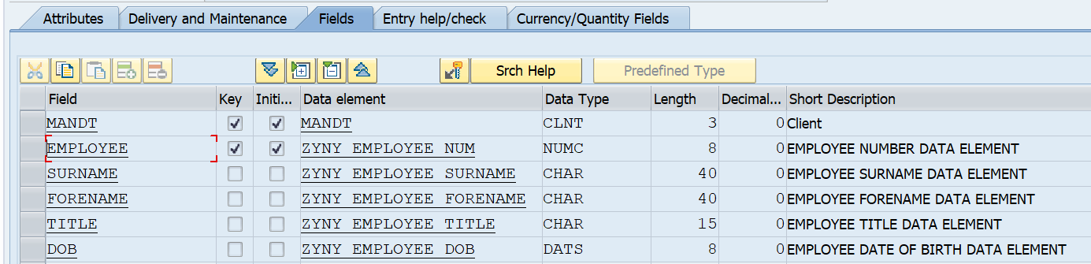

Now fill other fields and create their data elements and domain respectively.